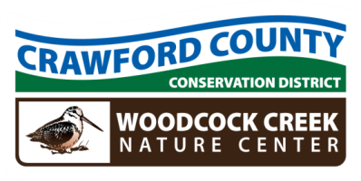

Crawford County Conservation District
Woodcock Creek Nature Center
21742 German Road – Meadville, PA 16335 – Phone: 814-763-5269
www.crawfordconservation.com

REGULAR MEETING AGENDA
Monday, Sept 8, 2025
4:15 PM

4:15 P.M. CALL TO ORDER ……………….…………………………………………………………………… Waddell
4:16 INTRODUCTION OF GUEST(S) ………………………………..………………………………. Waddell
4:17 APPROVAL OF MINUTES …………………………………………………..………………… Waddell
4:18 REVIEW AND REQUEST TO FILE TREASURER’S REPORT FOR AUDIT………… Dengler

4:20 COMMITTEE REPORTS
ACAP Update / Project Approval………………………………………………… Dilley
DGLVR Update …………………………….……………………………………………. McGill
FLP Update ………………………………………………………………………………… Crawford
4:35 UNFINISHED BUSINESS
None
4:35 NEW BUSINESS
SCC Per diem Policy comments due Oct 19 ……………………………….. Crawford
Security Updates ………………………………………………………………………. Waddell
4:45 COOPERATING AGENCY REPORTS

4:50 ADJOURN AND SIGNATURES

Next Meeting Date: Oct 13, 2025

